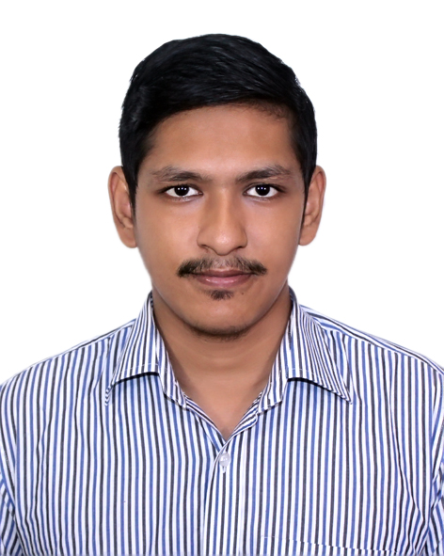
EMIL MICHAEL BOTLERO
Mailing Address: 147/L, East Raja Bazar, Farmgate,
Dhaka-100, Bangladesh, Cell No.: +880-1830288514,
For Emergency Contact: Mr. Sankar Botlero- 01869707070
E-mail: emilmichael000@gmail.com

Career Objectives
Future development and enhance my working capacities to be a part of professional team member with sheer determination & commitment. My goal is to work in a corporate environment where there is an opportunity of self-assessment and self-improvement.

Work Experience

- Office Administration
  - ST.John Vianney Hospital
  - January 2021 to Present

- Finance Officer
  - Prime bank Limited
- Internship (4 months)

Educational Qualification

- Bachelor of Business Administration (BBA) [2016-2019] Enrolling

  - Major in finance (CGPA:3.24 out of 4)
  - Notre Dame University Bangladesh, Motijheel, Dhaka.

- Higher Secondary Certificate (HSC) [2015]

  - College: Notre Dame College, Dhaka
  - Board: Dhaka
  - Subject: Business Studies
  - GPA & Grade: 4.42 (A)

- Secondary School Certificate (SSC) [2013]

  - School: St. Joseph Higher Secondary School, Mohammadpur
  - Board: Dhaka
  - Subject: Business Studies
  - GPA & Grade: 4.75 (A)

Professional qualification

- Graphics design (4 Month Course)
- Dimension IT and Software

Training and workshop

“Stakeholder Management” & “Sustainability Engagement”
- “Personal and social implications of the Self- Esteem”
- “Values and practices of Conflict Resolution”
- “Personal and political implications of the Dialogue of Cultures”
- “CV writing and interview techniques.”

Language

- Bengali – Mother tongue
- English –Reading, Writing, Speaking, Listening
- Hindi-Listening, Speaking

Computer Literacy

- MS Office Package (Word, MS Excel, MS Power Point),
- Graphic designs with Adobe Photoshop, Adobe Light room, Adobe Illustrator, E-mail operations etc.

Personal Qualitative Attributes

- Positive attitude towards assigned task.
- Able to do work under pressure with due care.
- Manage time effectively.
- Motivated to adjust in various work environments quickly.
- Co-operative in group Tasks

Extra-curricular

- Amal Foundation (2018-Present)
- Notre Dame University Business Club (2016-2019).

Personal Information

Name: Emil Michael Botlero
Father’s Name: Sankar Dominic Botlero
Occupation: Service
Mother’s Name: Probhati Clara Corraya
Occupation: Teaching
Date of Birth: 06 May, 1997
Nationality: Bangladeshi
Marital Status: Single
Religion: Christianity

References

Rev. Fr. Kamal A. Corraya  Executive Director  St. John Vianney Hospital  Tejgaon, Dhaka  Contact No: 017111591347 | MD. Rezaul Karim  Assistant Vice President &head of branch  Prime Bank Limited  Phone number: 01714069979

I, hereby declare that each of the information stated above is true and any willing mistake will result me in disqualification.



Emil Michael Botlero

